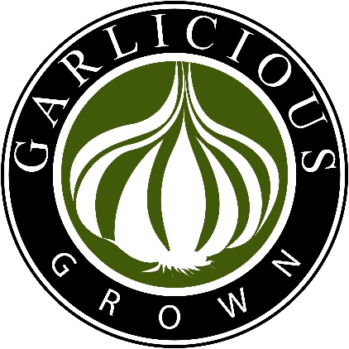
Black Garlic: This is not a variety of garlic, but a wonderful caramelized preparation of various garlic varieties. Garlic is stored under controlled temperature and humidity to produce tarry black cloves with umami flavours of sweet molasses. There are no additives, extra ingredients or preservatives, just pure garlic. Ready to spread on crackers, warm through an omelette or any number of other yummy alternatives, Australian grown purple garlic is raised in awesome conditions in the Braidwood region. Although shelf stable and not technically requiring refrigeration, due to its high moisture content it can mould if kept in a sealed container exposed to sun or heat. Refrigeration is recommended.
Smoked Powdered Garlic: Wonderful white garlic heads smoked over lemon myrtle, tea and sugar then powdered ready to use. Makes a wonderful addition to savoury dishes.
Powdered Black Garlic: Australian grown chemical free dehydrated and powdered black garlic – available in three varieties:
Plain - lovely on poached eggs or scattered on soup
Lemon Myrtle - super on fish or chicken
Rosemary - terrific for roast veg especially with lamb
Grown in beautiful conditions, dehydrated and ground ready to flavour your favourite dishes. Unlike commercial powdered garlic, this is salt free and pure garlic. Stored with a pulse to minimise caking risk. Remember not to shake over a hot pot to avoid adding moisture to your jar!
Winner of a 2015 RAS Fine Food medal for Regional Produce for Black Garlic cloves and for our wonderful Lemon Myrtle and Black Garlic Powder
Available at www.garliciousgrown.com.au

